WEEK – 5
MICROSERVICES WITH SPRING BOOT 3 AND SPRING CLOUD

CREATING MICROSERVICES FOR ACCOUNT AND LOAN
APPROACH
- Create two separate Spring Boot projects: account and loan with Spring Web dependency.
- Set ports in application.properties.
- Create REST controllers for each with dummy data (/accounts/{number}, /loans/{number}).
- Build and run both services using Eclipse or mvn spring-boot:run.
- Test both endpoints via browser using their respective localhost URLs.
CODE - Account
ApplicationController.java
package com.cognizant.account.controller;
import org.springframework.web.bind.annotation.GetMapping;
import org.springframework.web.bind.annotation.PathVariable;
import org.springframework.web.bind.annotation.RestController;
import java.util.Map;
@RestController
public class AccountController {
@GetMapping("/accounts/{number}")
public Map<String, Object> getAccountDetails(@PathVariable String number) {
return Map.of(
"number", number,
"type", "savings",
"balance", 234343);}}
AccountApplication.java
package com.cognizant.account;
import org.springframework.boot.SpringApplication;
import org.springframework.boot.autoconfigure.SpringBootApplication;
@SpringBootApplication
public class AccountApplication {
public static void main(String[] args) {
SpringApplication.run(AccountApplication.class, args);
}
}
OUTPUT
(for Account)
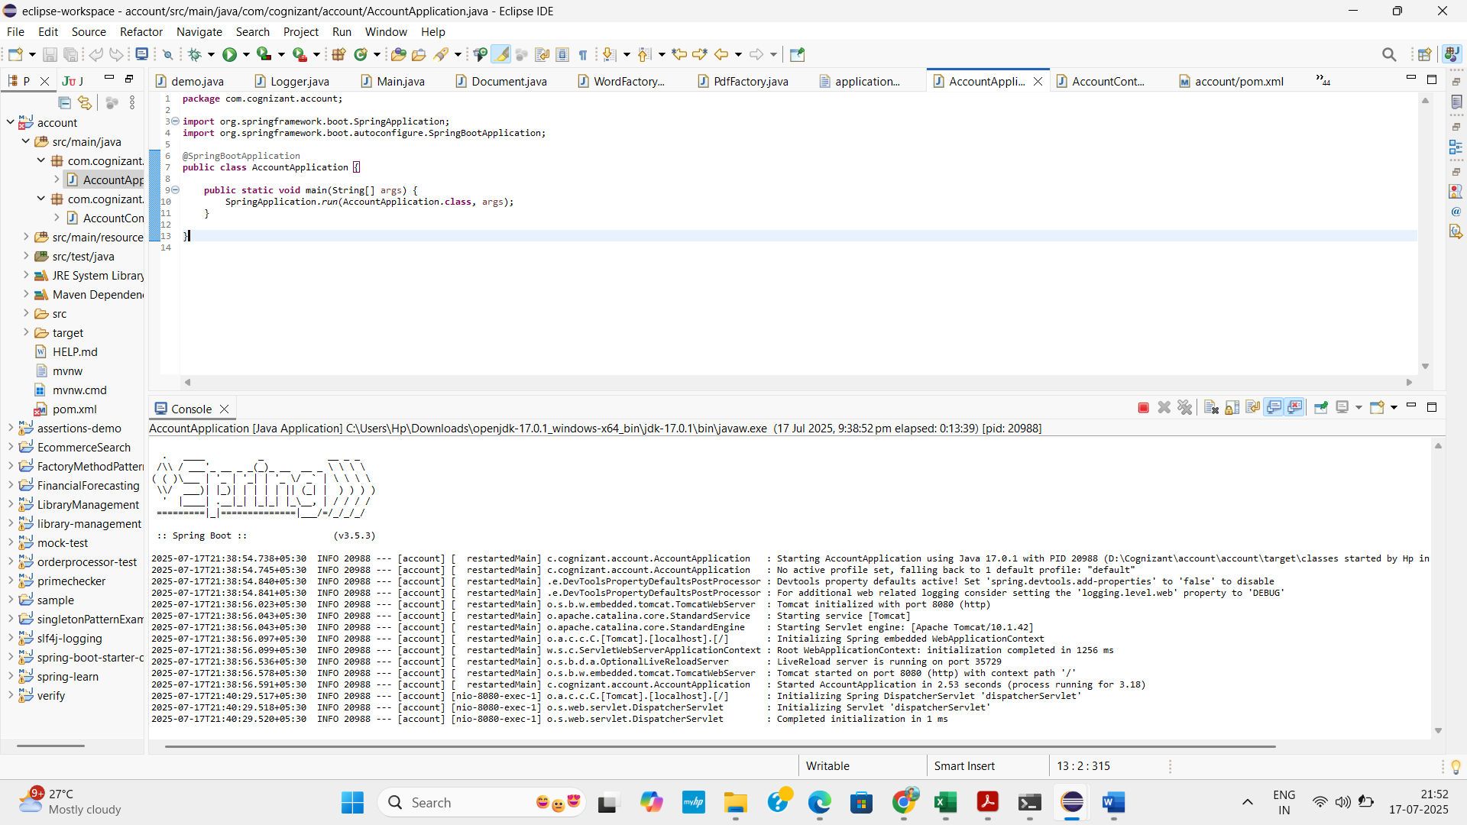

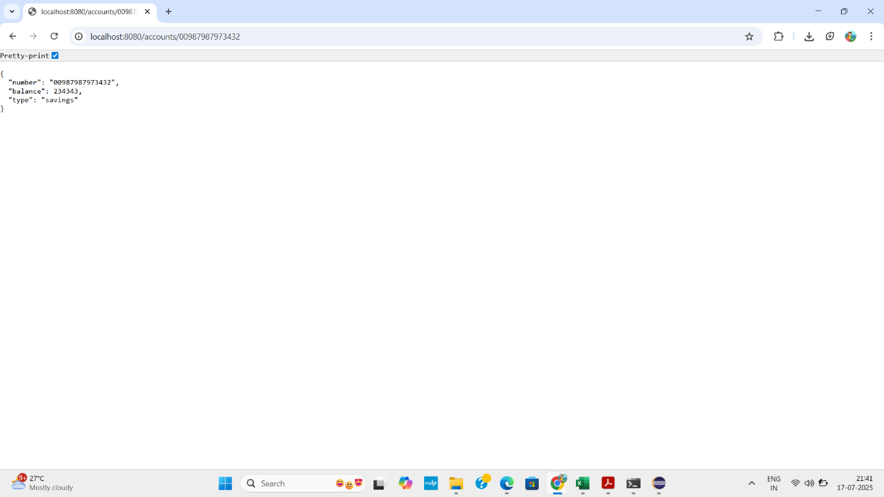

CODE – Loan
LoanController.java
package com.cognizant.loan.controller;
import org.springframework.web.bind.annotation.GetMapping;
import org.springframework.web.bind.annotation.PathVariable;
import org.springframework.web.bind.annotation.RestController;
import java.util.Map;
@RestController
public class LoanController {
@GetMapping("/loans/{number}")
public Map<String, Object> getLoanDetails(@PathVariable String number) {
return Map.of(
"number", number,
"type", "car",
"loan", 400000,
"emi", 3258,
"tenure", 18
);
}
}

LoanApplication.java
package com.cognizant.loan;
import org.springframework.boot.SpringApplication;
import org.springframework.boot.autoconfigure.SpringBootApplication;
@SpringBootApplication
public class LoanApplication {
public static void main(String[] args) {
SpringApplication.run(LoanApplication.class, args);
}
}
OUTPUT
(for loan)
